Adaptation Behavior in an AI-Assisted Agentic Browser Simulation

line 1: 1st Given Name Surname
line 2: dept. name of organization
(of Affiliation)
line 3: name of organization
(of Affiliation)
line 4: City, Country
line 5: email address or ORCID
line 1: 4th Given Name Surname
line 2: dept. name of organization
(of Affiliation)
line 3: name of organization
(of Affiliation)
line 4: City, Country
line 5: email address or ORCID
line 1: 2nd Given Name Surname
line 2: dept. name of organization
(of Affiliation)
line 3: name of organization
(of Affiliation)
line 4: City, Country
line 5: email address or ORCID
line 1: 5th Given Name Surname
line 2: dept. name of organization
(of Affiliation)
line 3: name of organization
(of Affiliation)
line 4: City, Country
line 5: email address or ORCID
line 1: 3rd Given Name Surname
line 2: dept. name of organization
(of Affiliation)
line 3: name of organization
(of Affiliation)
line 4: City, Country
line 5: email address or ORCID
line 1: 6th Given Name Surname
line 2: dept. name of organization
(of Affiliation)
line 3: name of organization
(of Affiliation)
line 4: City, Country
line 5: email address or ORCID

I. Introduction
This research focuses on adaptation behaviour in AI-assisted agentic browsing systems. Recent work on agentic AI, the Agentic Web, and WebAgents shows that these systems are designed to perform multi-step actions, retrieve information, and support user task completion [1]-[3]. While these technologies are advancing rapidly, their adoption depends not only on technical capabilities but also on how users perceive usefulness, ease of use, and trust when interacting with them [4]-[9].
Building on this rationale, this research investigates how users behave when interacting with an agentic browser simulation while completing tasks. The study focuses on how participants adapt to the AI assistant during use and whether prior technological or AI experience affects how quickly and effectively they adapt.
II. Positioning and Research Onion
This study is positioned within the fields of technology adoption research and AI trust, focusing on how users interact with AI-assisted systems. The Technology Acceptance Model (TAM) and related acceptance frameworks explain that perceived usefulness, perceived ease of use, and trust influence how users engage with new technologies [4], [5], [8], [9]. The methodological design of this study is illustrated in Figure 1.
- 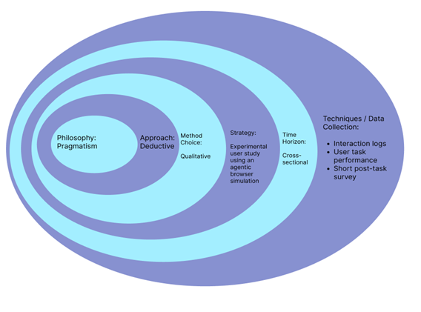
Figure 1. Research Onion illustrating the study's methodological design.

The layers of the research onion for this study are: Philosophy: Pragmatism;
Approach: Deductive;
Method Choice: Qualitative;
Strategy: Experimental user study using an agentic browser simulation;
Time Horizon: Cross-sectional;
Techniques / Data Collection: Interaction logs, user task performance, and short post-task survey.

These choices fit the study because the research begins with a hypothesis informed by previous technology acceptance and AI trust literature, making a deductive approach suitable [4]-[9]. A qualitative method is appropriate because the study is primarily concerned with interpreting how users adapt, hesitate, delegate, and describe their experience during interaction, rather than measuring attitude scores alone. An experimental user study is suitable because all participants will complete the same tasks in the same controlled simulation. A cross-sectional time horizon is appropriate because each participant will be observed in a single session. Finally, interaction logs, task performance, and a short post-task survey are used together to compare observed behaviour with participants' reports of their experience.
III. Background to this Research Theme
Recent research shows that agentic systems are moving beyond passive assistance and are increasingly able to act on the web, gather information, and complete multi-step tasks for users [1]-[3]. At the same time, technology adoption studies argue that usefulness, ease of use, and trust are central to whether users accept and engage with a new technology [4], [5], [8], [9]. Trust is especially important in AI systems because uncertainty, perceived risk, and confidence in the system can affect whether users rely on the system or avoid it [6], [7].
While this literature explains why users may accept AI systems, less attention is given to how users behaviorally adapt when they first interact with an AI-assisted browsing environment. This research, therefore, focuses on adaptation during use, examining how user behaviour evolves as participants complete tasks in an agentic browser simulation.
IV. Hypothesis
Users with prior technological or AI experience will adapt faster and use the AI assistant more effectively than inexperienced users in an agentic browser simulation.
V. Research Aim and Purpose Statement
The aim of this research is to investigate how users adapt to interacting with an agentic browser simulation when completing tasks without guidance.
The purpose of this qualitative experimental user study is to understand user adaptation to an AI-assisted agentic browser simulation for participants completing unguided web-based tasks in a controlled simulation environment; at this stage in the research, user adaptation is defined as the ease with which participants begin to use and delegate to the AI assistant while completing the tasks.
VI. Independent and Dependent Variables
To evaluate the hypothesis, the study considers both independent and dependent variables. The independent variables are the inputs that may influence users' adaptation. In this study, they include: prior technological or AI experience, and interaction stage during the session (early interaction vs later interaction). The dependent variable in this study is ease of adaptability to the AI-assisted browser simulation. This dependent variable will be measured through behavioural indicators, including the frequency of AI assistant use, task completion behaviour, user interaction patterns within the simulation, and delegation behaviour during task completion. Together, these indicators provide evidence of how easily participants adapt to the system.
VII. Participants, Research Site, and Control Variables
The participants in this study will be users with different levels of prior technological or AI experience. The research site will be a controlled, agent-based browser simulation developed in Unity, in which participants will complete the same web-based tasks. To keep the study consistent across participants, the simulation version, task set, starting state, and level of guidance will be kept fixed for all users.
References
[1] S. Hosseini and H. Seilani, "The role of agentic AI in shaping a smart future: A systematic review," Array, vol. 26, p. 100399, 2025.
[2] Y. Yang et al., "Agentic Web: Weaving the Next Web with AI Agents," arXiv preprint arXiv:2507.21206, 2025.
[3] L. Ning et al., "A Survey of WebAgents: Towards Next-Generation AI Agents for Web Automation with Large Foundation Models," arXiv preprint arXiv:2503.23350, 2025.
[4] F. D. Davis, "Perceived usefulness, perceived ease of use, and user acceptance of information technology," MIS Quarterly, vol. 13, no. 3, pp. 319-340, 1989.
[5] V. Venkatesh, M. G. Morris, G. B. Davis, and F. D. Davis, "User acceptance of information technology: Toward a unified view," MIS Quarterly, vol. 27, no. 3, pp. 425-478, 2003.
[6] S. Afroogh et al., "Trust in AI: progress, challenges, and future directions," Humanities and Social Sciences Communications, vol. 11, no. 1, p. 1568, 2024.
[7] X. Zhao et al., "How do consumers trust and accept AI agents? An extended theoretical framework and empirical evidence," Behavioural Sciences, vol. 15, no. 3, p. 337, 2025.
[8] A. T. Lee, R. K. Ramasamy, and A. Subbarao, "Understanding psychosocial barriers to healthcare technology adoption: A review of TAM and UTAUT frameworks," Healthcare, vol. 13, no. 3, p. 250, 2025.
[9] F. Ibrahim, J.-C. Munscher, M. Daseking, and N.-T. Telle, "The technology acceptance model and adopter type analysis in the context of artificial intelligence," Frontiers in Artificial Intelligence, vol. 7, p. 1496518, 2025.

